COS30002 AI for Games

Semester 1, 2019  
Learning Summary Report

Sam Huffer (101633177)

COS30002 AI for Games

Learning Summary Report

Sam Huffer (101633177)

Self-Assessment Details

The following checklists provide an overview of my self-assessment for this unit.

|  |  |  |  |  |  |
| --- | --- | --- | --- | --- | --- |
|  | Pass (P) | Credit (C) | Distinction (D) | High Distinction (Low HD) | (High HD) | |
| Self-Assessment (please tick) |  |  | ✔ |  |  |

*Self-assessment Statement*

|  |  |
| --- | --- |
|  | Included? (tick) |
| Learning Summary Report | ✔ |
| Time-boxed Demonstration Activity (Lab Test) in Doubtfire | ✔ |
| Complete Pass (“core”) task work, approved in Doubtfire | ✔ |

*Minimum Pass Checklist*

|  |  |
| --- | --- |
|  | Included? (tick) |
| Additional non-core task work (or equivalent) in a private repository and accessible to staff account. | ✔ |
| Spike Extension Report (for spike extensions) in Doubtfire | ✔ |
| Custom Project plan (for D and/or low HD), and/or High HD Research Plan document in Doubtfire (optional) | ✔ |

*Credit Checklist, in addition to Pass Checklist*

|  |  |
| --- | --- |
|  | Included? (tick) |
| Custom Project Distinction Plan document, approved in Doubtfire | ✔ |
| All associated work (code, data etc.) available to staff (private repository), for non-trivial custom program(s) of own design | ✔ |
| Custom Project “D” level documents in Doubtfire, to document the program(s) (structure chart etc) including links to repository areas | ✔ |

*Distinction Checklist, in addition to Credit Checklist*

|  |  |
| --- | --- |
|  | Included? (tick) |
| Custom Project “HD” level documents in Doubtfire, to document the program(s) (structure chart etc) including links to repository areas |  |

*Low High Distinction Checklist, in addition to Distinction Checklist*

|  |  |
| --- | --- |
|  | Included? (tick) |
| High Distinction Plan document, approved in Doubtfire |  |
| High Distinction Report document, in Doubtfire, which includes links to repository assets |  |
| All associated work (code, data etc.) available to staff (private repository) for your research work |  |

*High High Distinction (Research) Checklist, in addition to D/Low HD Checklist*

# Introduction

This report summarises what I learnt in COS30002 AI for games. It includes a self-assessment against the criteria described in the unit outline, a justification of the pieces included, details of the coverage of the unit intended learning outcomes, and a reflection on my learning.

*Complete the following sections. Red text in a box (like this section) is a comment on what needs to be included; these should be* ***deleted*** *for the final submission. Some text provided is “placeholder text” and should be changed. You are also encouraged to customise the format and cover page. Remember to change name and id in header! (Unless your name is Fred Smith (123456).)*

# Overview of Pieces Included

This section outlines the pieces that I have included in my portfolio…

*Describe the pieces you have included in your portfolio.*

*This should contain a* ***list*** *of all the pieces, along with a short statement of* ***why*** *each piece was included.*

# Coverage of the Intended Learning Outcomes

This section outlines how the pieces I have included demonstrate the depth of my understanding in relation to each of the unit’s intended learning outcomes.

## ILO 1: Software Development for Game AI (A)

*“Discuss and implement software development techniques to support the creation of AI behaviour in games”*

*Describe what you have included in your portfolio that demonstrates your ability in relation to this outcome.*

* *Pass: Identify where in your lab work, lab tests or core spike work that the topics that need to be discussed and implemented have been covered.*
* *Credit: Descriptions much contain depth and relate the concepts to each other, and implementations must demonstrate practical application.*
* *Distinction, High Distinction: relate to your project and/or research*

Task 1

Task 2

Task 3

Task 12?

Task 14

Task 15

Task 19

Task 20

*Task 21*

Task 22

## ILO 2: Graphs and Path Planning (G)

*“Understand and utilise a variety of graph and path planning techniques*.”

*Describe what you have included in your portfolio that demonstrates your ability in relation to this outcome.*

* *Pass: Identify where in your lab tests and/or spike work where you have explained or utilised this ILO.*
* *Credit: Evidence of depth in the portfolio work and explanations provided.*
* *Distinction, High Distinction: relate to your project and/or research*

Task 6

Task 17

Task 18

Task 19

Task 20

*Task 21*

## ILO 3: Force-based Agent Movement (S)

*“Create realistic movement for agents using steering force models*.”

*Describe what you have included in your portfolio that demonstrates your ability in relation to this outcome.*

* *Pass: Working implementations / demonstrations from the spike work.*
* *Credit. Additional work that extends the core spike work features*
* *Distinction, High Distinction: relate to your project and/or research*

Task 8

Task 9

Task 10

Task 11

Task 15

Task 16

Task 19

## ILO 4: Goals and Planning Actions (P)

*“Create agents that are capable of planning actions in order to achieve goals*.”

*Describe what you have included in your portfolio that demonstrates your ability in relation to this outcome.*

* *Pass: Working implementations / demonstrations from the spike work.*
* *Credit. Additional work that extends the core spike work features*
* *Distinction, High Distinction: relate to your project and/or research*

Task 4

Task 5

Task 6

Task 7

Task 10

Task 11

Task 14

Task 15

Task 16

Task 17

Task 18

Task 19

Task 20

*Task 21*

## ILO 5: Combine AI Techniques (X)

*“Combine AI techniques to create more advanced game AI*.”

*Describe what you have included in your portfolio that demonstrates you ability in relation to this outcome.*

* *Pass: Working implementations / demonstrations from the spike work.*
* *Credit. Additional work that extends the core spike work features*
* *Distinction, High Distinction: relate to your project and/or research*

Task 6

Task 9

Task 10

Task 11

Task 14

Task 15

Task 17

Task 18

Task 19

Task 20

*Task 21*

# Reflection

## The most important things I leant:

*Think about topics covered, but also other general things you may have learnt.   
Think about what you have learnt in this subject, and reflect on what you think were key learning points, or incidents in your personal experience. (Did you learn what you wanted/expected to learn?)*

* The underlying logic behind a number of AI movement behaviours that can be combined and modified to form more complex behaviour (i.e. alignment, cohesion and separation).
* How search algorithms and networks can be applied in AI movement to make decisions and follow paths.
* Pros and cons of different ways of having AIs move in a boxed graph-based environment in relation to customizability of the simulation space by the user.

## The things that helped me most were:

*List and explain*

* The lecture notes that outlined the logic required for particular movement behaviours, as they gave me a basis for the implementation of those behaviours and gave me ideas to work with in case that implementation ran into issues and I needed to devise an alternative.
* The lab and spike work, as it allowed me to explore the topic and build my understanding of it and competencies it required by working through each requirement of the task.

## I found the following topics particularly challenging:

*List and explain. If none, explain why!*

None of the topics were especially challenging conceptually; I found they were all reasonably straightforward. The challenges came from the implementation, such as:

* Implementing the detection of objects using feelers as outlined in the lecture slides: there were one or two aspects of how to implement it that didn’t click in my mind until after the submission of the task, resulting in me improvising an alternative obstacle-avoidance method using two detection circles.
* Balancing the group steering behaviours in **Task 11** (double check) to create functional and nice-looking steering behaviours: getting the magnitudes of the different forces and combining them all was tricky to do. I managed it somewhat, but not to the point of replicating the smoothness of the behaviours as demonstrated in the lecture, nor to the point of getting the prey agents circling around the simulation space.

## I found the following topics particularly interesting:

*List and explain. Remove if none.*

* Force-based steering behaviours and emergent group behaviour (including patrolling): these behaviours appear to form the basis of how enemy AIs move in, for example, first- and third-person shooters and adventure games, and thus struck me as being of particular practical value.
* Predicting the location of a target an AI is shooting at, another fundamental behaviour required of any game involving AIs shooting each other or the player.
* Graph-based locations and movement: this seemed an interesting alternative means of moving around a virtual space besides force-based steering.

## I feel I learnt these topics, concepts, and/or tools really well:

*List and explain. If none, explain why! Refer to your portfolio pieces for evidence to support your claims.*

## I still need to work on the following areas:

*List and explain. If none, explain why! Refer to your portfolio pieces.*

## My progress in this unit was …:

During the semester, I worked consistently on my tasks, handing almost all of the lab and spike work in on time. The only gaps in my progress during the semester according to the burndown chart were during the mid-semester break, when there were no tasks due and I elected to focus on work for my concurrent capstone project, and while I was working on upcoming assignments from other units while waiting for the release of the instructions of Task 18: Navigation with Graphs and the credit tasks. Otherwise, I have been consistently working on each week’s tasks from that week’s tutorial until the tasks’ completion.

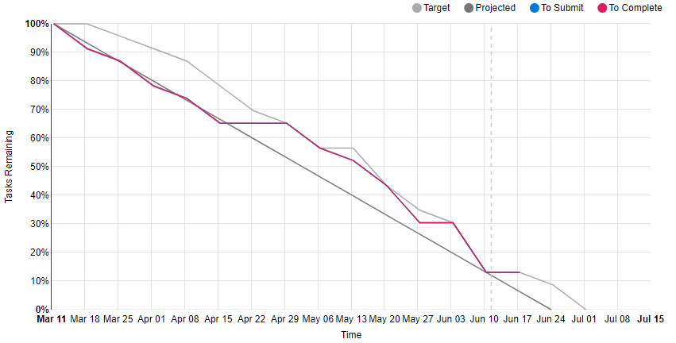

Figure : My burndown chart for AI for Games.

## This unit will help me in the future:

*How will the things you learnt relate to the rest of your studies, and career?  
What have you learnt that will be valuable for you in the future?*

## If I did this unit again I would do the following things differently:

*List and explain, how will you approach learning in the future?   
What things worked well, but what could you change to make sure you did better next time?*

## Other…:

*Add any other reflections you think help you demonstrate your learning*

# Conclusion

In summary, I believe that I have clearly demonstrate that my portfolio is sufficient to be awarded a …. grade.

*Add more points if you wish, but don’t add anything you haven’t already mentioned in an earlier section.*